
North America Mass Flow Task Force
SEMI Standards Spring 2020 Meeting
March 30, 2020, 11.00am-12 noon
SEMI HQ,
673 S. Milpitas Blvd
Milpitas, CA 95035

Note: Mass Flow Task force meeting is as scheduled, but solely via Web conferencing due to COVID-19.

AGENDA

Item# | Topic | Time
1 | Welcome, Call to Order | 11:00 – 11:05am
1.1 | Introductions | 11:00 – 11:05am
1.2 | Required Elements (Membership requirements, Antitrust and Intellectual Property Reminders, Effective Meeting Guidelines) | 11:00 – 11:05am
1.3 | Agenda Review | 11:00 – 11:05am
2 | Review of Previous Meeting Minutes | 11:05- 11:10am
2 | 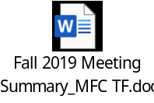 | 11:05- 11:10am
3 | Old Business: | 11:10 – 11:30am
3.1 | Review Ballot Results SEMI E12.  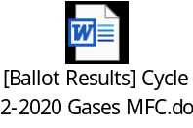 | 11:10 – 11:30am
3.2 |  | 11:10 – 11:30am
3.3
4 | New Business: | 11:30-11:40 am
4.1 | SNARF for New Standard: Specification for Location and Dimensions for Power Connectors and EtherCAT Ports in Mass Flow Controller and Mass Flow Meters.  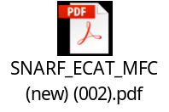 | 11:30-11:40 am
5 | Action Items Review | 11.40-11:50am
6 | Next Meeting and Adjournment | 11:50-11:55am
6.1 | Next meeting will be held at SEMICON West Standards Meeting on July 20, 2020 in San Francisco, CA

Teleconference and Web Meeting Information:

Please make sure RingCentral meetings app is installed on your device prior to joining the meeting

Join from PC, Mac, Linux, iOS or Android: https://meetings.ringcentral.com/j/1488080977
Or Telephone:
Dial (for higher quality, dial a number based on your current location):
US: +1(773)2319226
Meeting ID: 148 808 0977
International numbers available: https://meetings.ringcentral.com/teleconference

